**Influencer Marketing Analytics**

**Overview**

For this analysis, we looked at data from 20 lululemon global ambassadors involved in our last campaign. For this campaign, lululemon paid each of the ambassadors a marketing fee of $1-$2M and tracked their social media posts for three months.

**The total marketing spend for this segment was $23 million and resulted in $33 million customer purchases, for a Total ROI of 43%. The average ROI across influencers was 14%.**

**Customer Acquisition Costs**

The average customer acquisition costs (CAC) for each of the influencers are shown in the table below.

**Of each of the channels, blogs have the highest CAC of $5.68 and TikTok has the lowest CAC at ~$0.01 per acquisition**

**Based on CAC, we should focus on influencers who have a strong presence on TikTok, Facebook, and Instagram.**

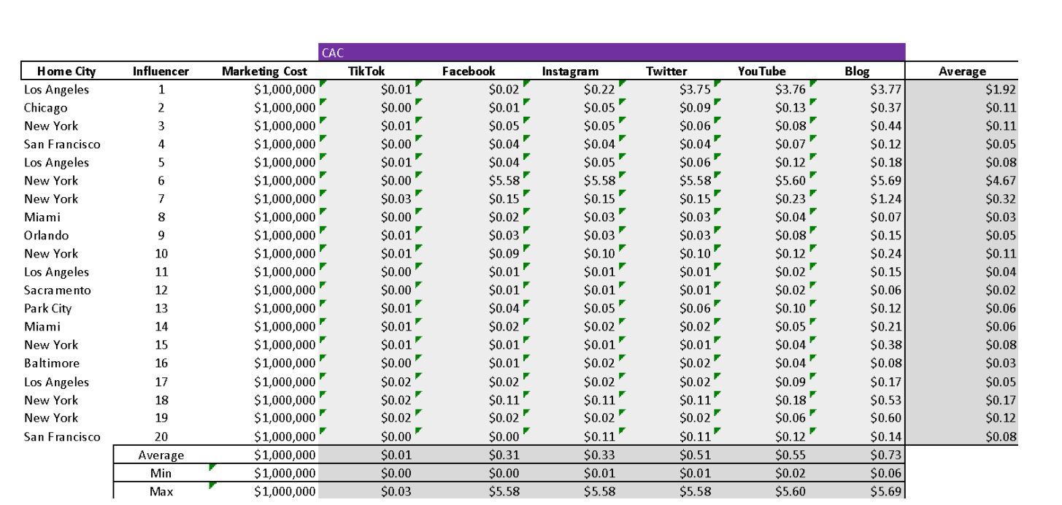

**Conversion Rates**

We also tracked conversion rates, which varied by influencer and by channel. The table below summarizes the conversion rates per influencer.

**The worst performing influencer had conversion rates of 5% and the highest performing had conversion rates of 34%. On average, blogs had the highest conversation rates and YouTube had the lowest. Based on conversion rates, we should focus on influencers who have a strong presence on Blogs, Instagram, and Facebook.**

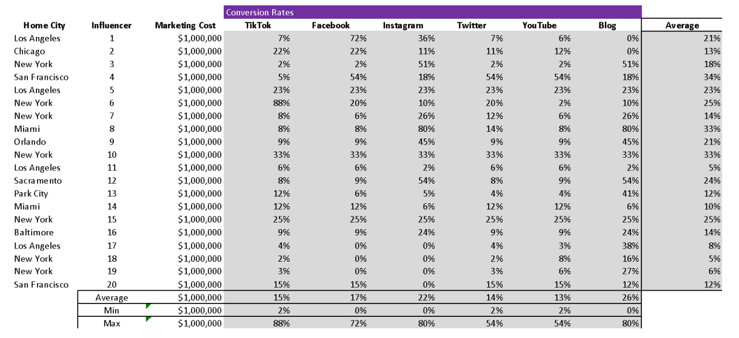

**Other Considerations**

**The data we have been given above is on the basis of the data of global athletes who are renowned globally so the data is according to that and ROI and other such factors are dependent on that as well but when you consider Local ambassadors the cost on marketing would be lower and because of their local fame we might get a good amount of ROI on them, Their cost of acquisition will be lower as well and they still have a substantial amount of following on social media as influencers.**